**Test Plan**

**Introduction**

The objective our test plan is to find and report as many bugs as possible to improve the integrity of our program. Although exhaustive testing is not possible, we will exercise a broad range of tests to achieve our goal.

The test plan document describes the plan for testing the GPS signals jamming detection prototype. It provides test personnel with the necessary approach to validate that each process performs correctly and that the requirements of the system have been satisfied. This test plan will provide the following:

* The test scope, focus areas and objectives
* The test responsibilities
* Detail the approach and strategy for testing of the solution
* Describe the planning, test case preparation and scheduling, including resource requirements
* Explain the execution, results documentation and review of the testing
* Provide the test cases which will be executed for this testing effort
* Any risks, issues, assumptions and test dependencies
* The test schedule and major milestones
* The test deliverables

**Scope**

The test document mainly targets the GPS jamming detection test that will be conducted jamming detection algorithm prototype testing and validating data in report output as per Requirements Specifications provided by Rohde & Schwarz. It includes the flowing:

1. In Scope: Functional Testing for the following modules are in Scope of Testing

* Loading
* System Performance and Functionality
* Test bench

1. Out Scope: None GPS jamming signal Testing was not done for this application.

**Testing Process**



Figure 1: Test Process Flow

1. Organize Project involves creating a System Test Plan, Schedule & Test Approach, and assigning responsibilities.
2. FPGA System Test involves identifying Test Cycles, Test Cases, Entrance & Exit Criteria, and Expected Results.
3. Matlab Codes Testing includes verifying functionality, codes bugging, and errors management.
4. Build Test Environment includes test benches, software, and hardware set-up.
5. Execute System Tests – The tests identified in the Design/Implementation Test Procedures will be executed. All results will be documented and Bug Report.
6. Documented all test scenarios when all pre-defined exit criteria have been achieved.

**Types of Testing Performed**

* Loading (input-read files and output-write/store files): make sure the major functionality is working fine, build can be accepted and Testing can start.
* System Performance: scenarios were tested to make sure important functionality in the application works as intended without any errors.
* Algorithm Verification: ensure that algorithm does not contain any defects or program bugs.

**Test Approach**

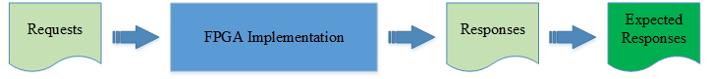

Figure 2: Generate test inputs (requests) for testing.

1. **White box testing:** this testing based on program code that we executed every statement on program to ensure the majority of bugs within the system will be identified and it is error free. We are done the following testing:

* Data processing
* Calculation correctness tests

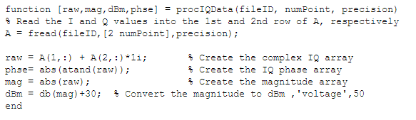

Figure 3: IQ Data processing

1. **Black box testing:** ensure the system output as expected.

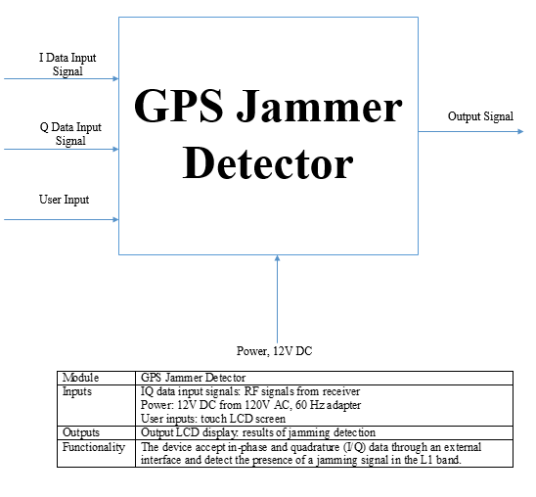

Figure 4: Black Box Testing.

**Items Not Tested**  
Signal Receiver connectivity with the third party system was not tested, as the connectivity could not be established due to some technical limitations. This can be verified during UAT (User Acceptance Testing) where the connectivity is available or can be established.

FPGA Implementation was not tested due to the following reasons. 1) The testing schedule is tight, the start of the testing is delayed due to design tasks, and test cannot be extended beyond the scheduled start date. 2) Defects are found at a late stage of the cycle or at a late cycle; defects discovered late are most likely be due to unclear specifications and are time consuming to resolve.

**Exit Criteria**

* All test cases should be executed – **Yes**
* All defects in Critical, Major, Medium severity should be verified and closed – **Yes**

**Recommendations**

As the Exit criteria was met and satisfied as mentioned in test plan, this application is suggested to ‘Go Live’ by the Testing team. Appropriate User acceptance testing should be performed before ‘Go Live’.